# ASSESSMENT TO KEEP LEARNERS ACTIVE

**S.1 PHYSICS TIME: 2 hours**

NAME:…………………………………………………………………….STREAM…………

**INSTRUCTIONS**

* Answer all questions in section A and any one in section B in the space provided.
* You may use non- programmable scientific calculator.

## SECTION A (attempt all questions in the space provided)

1. During class activity, the students were tasked to find the length of their classroom. Osman found out that the classroom length is **50-foot spans** meanwhile John obtained **12 meters**.
   1. Why do you think there are differences between the values obtained by the two students…………………………………………………………………….....................

............................................................................................................................(01 mk)

* 1. Which of the two values obtained is an estimated value? (01 mk)
  2. Which of the two values obtained is the actual value ? (01 mk)
  3. Who obtained the actual value of the length of classroom?. (01 mk)

e) How can we improve the reliability of an estimate?...........................................

………………………………………………………………………………….(01 mk)

1. A senior one student poured Potassium permanganate crystals in a large beaker containing water as shown below and left for some time to settle. He was surprised and puzzled by the motion that he saw.
   1. 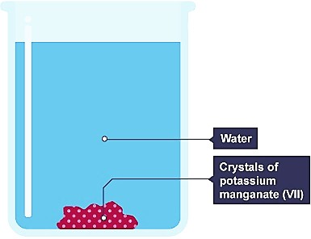Help the student understand the above scenario by explaining to him what happens after some time. (05 mks)

…………………………………………………………………

…………………………………………………………………

…………………………………………………………………

…………………………………………………………………

………………………………………………………………………………………………

………………………………………………………………………………………………

………………………………………………………………………………………………

## The diagram shows the shape and dimensions of Peter’s dining room.

(a) Peter wants to buy a carpet for his room. If one roll of a



**2m** carpet covers **15 m2**. How many rolls of the carpet will he need to buy? (10 marks)

# 6m 4m

**8m**

……………………………………………………………………………………………………

………………………………….………………………………………………………………

……

……

………………………………………………………………………………….……………………

…………………………………………………………………………………………………………

………………….……………………………………………………………………………………

# 3m

………………………………………………………………………………………………………………………………………………….…………

……………………………………………………………………………………………………………………………………….……………………

…………………………………………………………………………………………………………………………….………………………………

………………………………………………………………………………………………………………….…………………………………………

……………………………………………………………………………………………………….……………………………………………………

…………………………………………………………………………………………………………………………………………………………….

.……………………………………………………………………………………………………………………………………….…………………

……………………………………………………………………………………………………………………………….……………………………

…………………………………………………………………………………………………………………….………………………………………

………………………………………………………………………………………………………….…………………………………………………

……………………………………………………………………………………………………………………………………………………………

…………………………………………………………………………………………………………….………………………………………………

………………………………………………………………………………………………….…………………………………………………………

……………………………………………………………………………………….……………………………………………………………………

…………………………………………………………………………….………………………………………………………………………………

……………………………………………………………………………………………………………………………………………………………

……………………………………………………………………………….……………………………………………………………………………

…………………………………………………………………….………………………………………………………………………………………

………………………………………………………….…………………………………………………………………………………………………

……………………………………………….……………………………………………………………………………………………………………

……………………………………………………………………………………………………………………………………………………………

………………………………………………….…………………………………………………………………………………………………………

……………………………………….……………………………………………………………………………………………………………………

1. 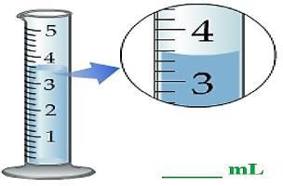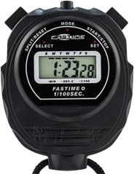One given day students from primary school came to your school to tour the school laboratory but in absence of your class physics teacher you have been requested to guide them know the name and use of each of the following measuring instruments. (10 marks)

**A**

**B**

**A** ………………………………………………………………………………………………

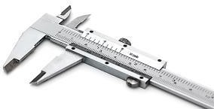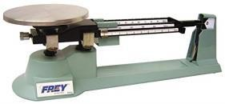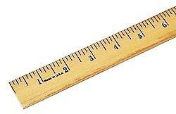

**C**

**D**

**E**

………………………………………………………………………………………………

**B** …………………………………………………………………………………………….

………………………………………………………………………………………………

**C** ………………………………………………………………………………………………

…………………………………………………………………………………………….

**D** ………………………………………………………………………………………………

………………………………………………………………………………………………

**E** …………………………………………………………………………………………….

………………………………………………………………………………………………

1. A golden-coloured **cube** that measures **2cm** by **2cm** by **2cm** and weighs **40 g** is handed to you. The person wants you to buy it for **$1,000,000**, saying that is a golden treasure. Is it gold? Should you buy it? (Given that the density of pure gold is **19.3 g/cm3 ) (5 marks)**

………………………………………………………………………………………………

………………………………………………………………………………………………

………………………………………………………………………………………………

………………………………………………………………………………………………

………………………………………………………………………………………………

………………………………………………………………………………………………

………………………………………………………………………………………………

………………………………………………………………………………………………

………………………………………………………………………………………………

1. The figure below shows one of the factors affecting diffusion. Study it carefully and answer the questions that follow. (05 marks)
   1. 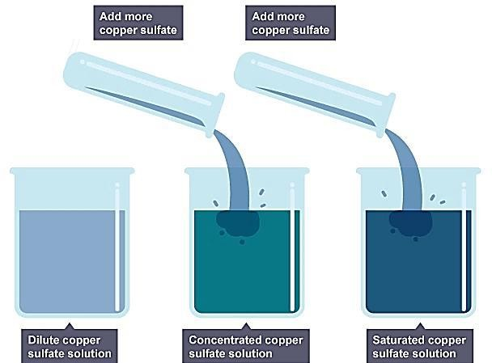Name the factor affecting the rate of diffusion shown in the figure…………………………….

………………………………………………...

* 1. Explain how it affects the rate of diffusion using particle theory of matter………………………

……………………………………………………

……………………………………………………

……………………………………………………

……………………………………………………

……………………………………………………

……………………………………………………

……………………………………………………

……………………………………………………

……………………………………………………

……………………………………………………

…………………………………………………….

1. The figure below is why balloons and tyres burst if you blow them up too much. It is also why deodorant spray cans carry warning signs to tell you not to leave them in the sunshine. If they get too hot, they may explode. (05 marks )

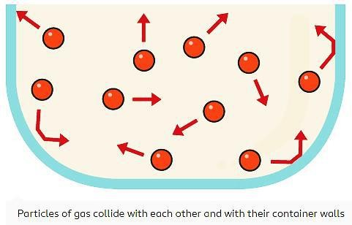Briefly explain the effect of heat on gas molecules in the tyres using particle theory of matter.

………………………………………………………………

………………………………………………………………

………………………………………………………………

………………………………………………………………

………………………………………………………………

………………………………………………………………

………………………………………………………………

………………………………………………………………

………………………………………………………………

………………………………………………………………

……………………………………………………………….

1. One rainy day one of your community members was struck by lightning and his body was having third degree skin burns and deep wounds. Most community members claimed it was witchcraft, maybe they are right or there maybe another better explanation to this scenario using knowledge of states of matter.

Explain to the community members what state of matter lightening is giving three more examples of other substances that fall in the same state of matter as lightening (05 marks )

………………………………………………………………………………………………

………………………………………………………………………………………………

………………………………………………………………………………………………

………………………………………………………………………………………………

………………………………………………………………………………………………

………………………………………………………………………………………………

………………………………………………………………………………………………

………………………………………………………………………………………………

………………………………………………………………………………………………

………………………………………………………………………………………………

………………………………………………………………………………………………

1. Convert the following

0.007kg\m3 to g\cm3

………………………………………………………………………………………………………………………………………………………………………………………………………………………………………………………………………………………………………………………………………………………………………………………………………………………………………………………………………………………………………………………………………………………………………………..

276gcm-3 to kgm-3

………………………………………………………………………………………………………………………………………………………………………………………………………………………………………………………………………………………………………………………………………………………………………………………………………………………………………………………………………………………………………………………………………………………………………………

10.Two forces of 3N and 4N act on an object at right angle. caliculate the resultant force

………………………………………………………………………………………………………………………………………………………………………………………………………………………………………………………………………………………………………………………………………………………………………………………………………………………………………………………………………………….

# SECTION B (attempt any one question in this section) Question one

SCENARIO;

In a certain school, the senior one classroom block is located about 100metres from the school latrines, however on some hot days, these learners sense a bad smell from these latrines and this affects their afternoon lessons.

**SUPPORT;**

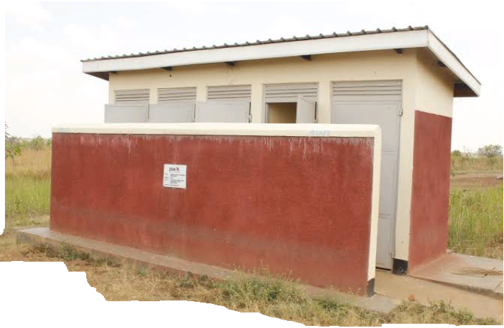

**Task**

1. Explain why learners are able to detect this bad smell yet their class room is far from the latrines
2. Advice these learners on the possible measures they can take to reduce this bad smell

**Good luck**